Partial / residual correlation: EURUSD and EURGBP
Method 07 / daily log returns / leave-currency-out USD factor / Alpari D1 full available history

Study setup
Logical pair: EURUSD , EURGBP
Broker symbols: EURUSD_i , EURGBP_i
Snapshot: 2026-11-03_majors_alpari_D1
Timeframe: D1
Matched return window: 1999-01-06 to 2026-11-02 (UTC bar dates)
Matched return count n: 7127
Dropped unfinished last bar dated 2026-11-03 UTC after a tick-volume check against the prior complete day.
USD-strength sign rule: minus log return when USD is the quote (EURUSD, GBPUSD, AUDUSD, NZDUSD); plus log return when USD is the base (USDJPY, USDCHF, USDCAD). EURGBP is never a constituent.
Control z constituents (5): AUDUSD, NZDUSD, USDJPY, USDCHF, USDCAD
z_t = equal-weight mean of those USD-strength returns on the same day
Complete matched rows (Excel): EURUSD-EURGBP_Partial_D1.xlsx
Complete matched rows (HTML table): EURUSD-EURGBP_Partial_D1_data.html

Method carried forward
Partial / residual correlation regresses each matched daily log return of close, ln(close_t / close_t-1), on the same leave-currency-out USD strength factor z, then takes Pearson correlation of the two residual series. Quotes are not inverted. z is the equal-weight mean of USD-strength returns from other majors that do not share a non-USD currency with either leg; EURGBP is never a constituent. USD-strength is minus the log return when USD is the quote (EURUSD, GBPUSD, AUDUSD, NZDUSD) and plus the log return when USD is the base (USDJPY, USDCHF, USDCAD). OLS uses an intercept on each leg. rho_partial is symmetric under swap of the two symbols. It describes leftover linear co-movement after removing linear z; it is not a cause, not a lead, and not a trading signal. Daily rows are not independent and residuals are estimated, so the two-sided p-value and Fisher interval are secondary. Same-sample raw Pearson r is a side check only.

Regression on z
leg | intercept_a_or_c | slope_b_or_d | R2
EURUSD | -1.492e-05 | -0.89418222 | 0.54208082
EURGBP | 2.131e-05 | -0.15257243 | 0.02235636

Results
rho_partial: 0.492957
Two-sided p-value: 0
Approximate 95% Fisher interval: [0.475178, 0.510333]
Same-sample raw Pearson r: 0.439919
rho_partial minus r: 0.053038

Conclusion
Over 7127 matched daily rows for EURUSD and EURGBP after removing a leave-currency-out USD factor built from 5 constituents, rho_partial is 0.4930 (positive, moderate residual linear link in this sample). Approximate 95% Fisher interval: [0.4752, 0.5103]. Same-sample raw Pearson r is 0.4399 (partial minus r = 0.0530). Leg R-squared on z: EURUSD=0.5421, EURGBP=0.0224. Two-sided p under the usual independent-pairs model is 0; residuals are estimated and daily FX rows are linked, so treat p as secondary. This does not establish cause, lead-lag, or a lasting trading rule.

Charts
Daily closes
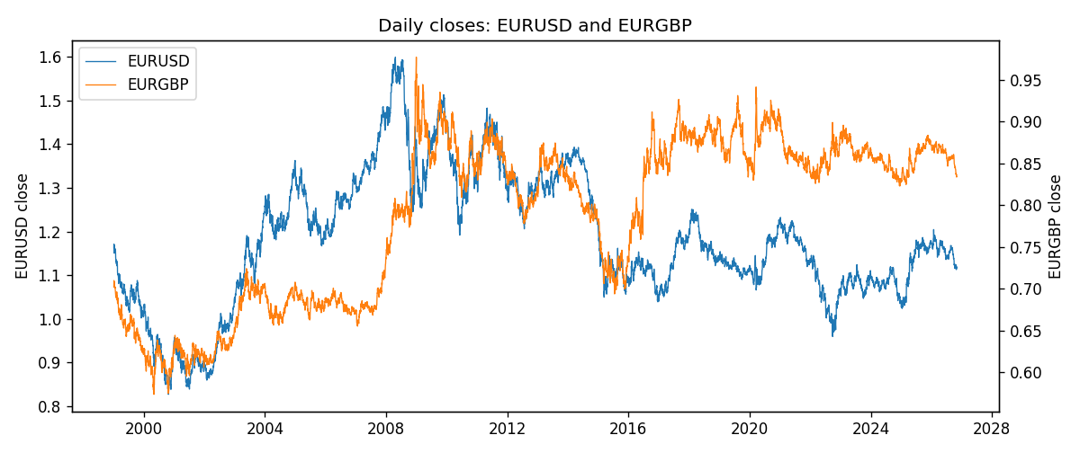
Log returns and control z
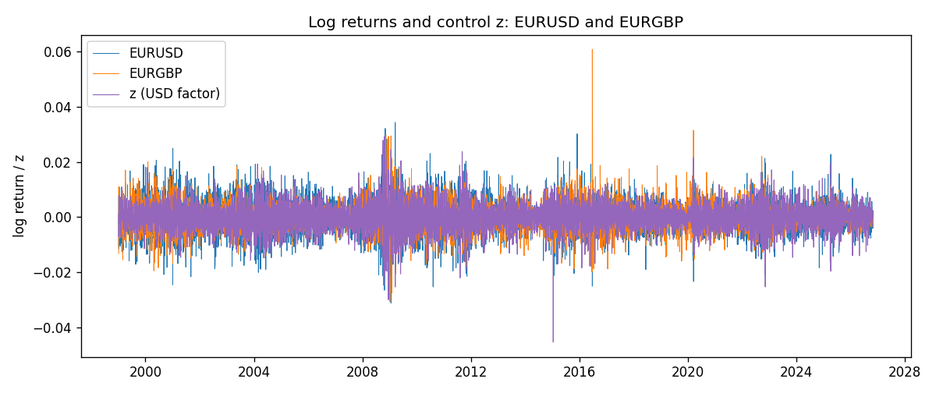
Residual scatter e_x vs e_y
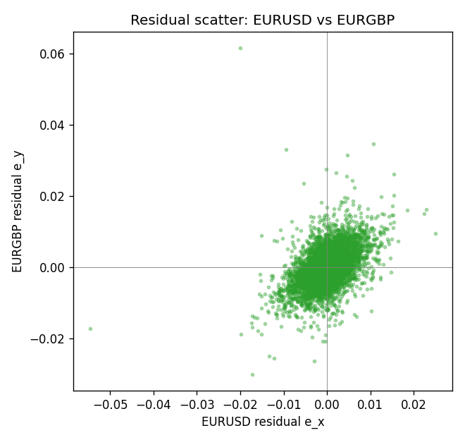

Data report
Every matched row that entered the partial correlation is stored in the sibling Excel workbook named EURUSD-EURGBP_Partial_D1.xlsx. That file is the complete data archive for redrawing charts. Embedding all rows as a Word table is impractical at this length; the Word file holds the column list, column summaries, and the first and last 15 matched rows.
Columns: time, EURUSD_open, EURGBP_open, EURUSD_high, EURGBP_high, EURUSD_low, EURGBP_low, EURUSD_close, EURGBP_close, EURUSD_tick_volume, EURGBP_tick_volume, EURUSD_spread, EURGBP_spread, EURUSD_real_volume, EURGBP_real_volume, EURUSD_log_return, EURGBP_log_return, usd_strength_AUDUSD, usd_strength_NZDUSD, usd_strength_USDJPY, usd_strength_USDCHF, usd_strength_USDCAD, z, EURUSD_fitted, EURGBP_fitted, EURUSD_resid, EURGBP_resid
Column summaries (matched calculation rows)
column | count | mean | std | min | 25% | 50% | 75% | max
EURUSD_open | 7127 | 1.1819407 | 0.15065555 | 0.8272 | 1.086455 | 1.16615 | 1.294285 | 1.5995
EURGBP_open | 7127 | 0.78791082 | 0.09637243 | 0.5734 | 0.6884 | 0.83449 | 0.8655 | 0.9769
EURUSD_high | 7127 | 1.1870746 | 0.15125674 | 0.8326 | 1.09055 | 1.17128 | 1.29974 | 1.6038
EURGBP_high | 7127 | 0.79099288 | 0.09674788 | 0.5789 | 0.6906 | 0.83742 | 0.868415 | 0.9799
EURUSD_low | 7127 | 1.1769341 | 0.14996546 | 0.8227 | 1.082375 | 1.16257 | 1.288915 | 1.5865
EURGBP_low | 7127 | 0.78520819 | 0.09619038 | 0.5682 | 0.6864 | 0.83222 | 0.86303 | 0.9661
EURUSD_close | 7127 | 1.1819858 | 0.15061943 | 0.8267 | 1.08652 | 1.16617 | 1.294345 | 1.5997
EURGBP_close | 7127 | 0.7879552 | 0.09637142 | 0.5735 | 0.6884 | 0.83458 | 0.86556 | 0.977
EURUSD_tick_volume | 7127 | 103994.86 | 174033.72 | 469 | 9542.5 | 53148 | 99923.5 | 1471626
EURGBP_tick_volume | 7127 | 87771.585 | 145890.89 | 332 | 6734 | 44866 | 82002 | 1424684
EURUSD_spread | 7127 | 19.176652 | 16.472988 | 0 | 8 | 12 | 20 | 50
EURGBP_spread | 7127 | 21.129928 | 19.050945 | 0 | 4 | 13 | 40 | 50
EURUSD_real_volume | 7127 | 4.0656436e+10 | 1.6756658e+11 | 0 | 0 | 0 | 0 | 3.6149665e+12
EURGBP_real_volume | 7127 | 2.8086114e+10 | 1.3572254e+11 | 0 | 0 | 0 | 0 | 3.5726265e+12
EURUSD_log_return | 7127 | -3.8e-07 | 0.00580028 | -0.03123819 | -0.00324243 | 8.31e-06 | 0.00325629 | 0.03433183
EURGBP_log_return | 7127 | 2.379e-05 | 0.00487339 | -0.03067367 | -0.00262314 | -9.978e-05 | 0.00256668 | 0.06075387
usd_strength_AUDUSD | 7127 | -3.23e-05 | 0.0075548 | -0.0806166 | -0.00415332 | -0.00029027 | 0.00385041 | 0.08602525
usd_strength_NZDUSD | 7127 | -2.447e-05 | 0.00764665 | -0.05966839 | -0.00459119 | -0.00024001 | 0.00423198 | 0.07027433
usd_strength_USDJPY | 7127 | 5.336e-05 | 0.00621278 | -0.03908203 | -0.00319557 | 0.00013026 | 0.00340928 | 0.05184024
usd_strength_USDCHF | 7127 | -7.023e-05 | 0.006591 | -0.19545699 | -0.00334576 | 8.055e-05 | 0.00331687 | 0.09051364
usd_strength_USDCAD | 7127 | -7.67e-06 | 0.00514753 | -0.03859748 | -0.0028338 | 5.597e-05 | 0.00272861 | 0.03436319
z | 7127 | -1.626e-05 | 0.0047759 | -0.04542184 | -0.0027024 | 1e-08 | 0.00273791 | 0.0291122
EURUSD_fitted | 7127 | -3.8e-07 | 0.00427053 | -0.02604653 | -0.00246311 | -1.493e-05 | 0.00240152 | 0.04060048
EURGBP_fitted | 7127 | 2.379e-05 | 0.00072867 | -0.00442041 | -0.00039642 | 2.131e-05 | 0.00043362 | 0.00695143
EURUSD_resid | 7127 | 0 | 0.00392504 | -0.05454192 | -0.00211054 | -2.251e-05 | 0.00215203 | 0.02493885
EURGBP_resid | 7127 | -0 | 0.0048186 | -0.03003527 | -0.00266348 | -0.00014842 | 0.00253584 | 0.06161172
First 15 matched rows (selected columns)
time | EURUSD_close | EURGBP_close | EURUSD_log_return | EURGBP_log_return | z | EURUSD_fitted | EURGBP_fitted | EURUSD_resid | EURGBP_resid
1999-01-06 | 1.1623 | 0.7019 | -0.011547966 | -0.013303338 | 0.0013918159 | -0.0012594553 | -0.00019104154 | -0.010288511 | -0.013112296
1999-01-07 | 1.1712 | 0.7097 | 0.0076280636 | 0.011051402 | -0.00717622 | 0.0064019301 | 0.0011162045 | 0.0012261335 | 0.0099351973
1999-01-08 | 1.1585 | 0.7062 | -0.010902799 | -0.004943862 | 0.00089151303 | -0.00081209337 | -0.00011470911 | -0.010090706 | -0.0048291529
1999-01-11 | 1.1503 | 0.7053 | -0.007103287 | -0.0012752393 | -0.0063849374 | 0.0056943792 | 0.00099547659 | -0.012797666 | -0.0022707159
1999-01-12 | 1.1555 | 0.7077 | 0.0045103728 | 0.0033970309 | 0.0078557747 | -0.0070394123 | -0.0011772634 | 0.011549785 | 0.0045742943
1999-01-13 | 1.1681 | 0.708 | 0.010845346 | 0.00042381861 | 0.0024568143 | -0.0022117579 | -0.00035353093 | 0.013057104 | 0.00077734954
1999-01-14 | 1.1681 | 0.7066 | 0 | -0.0019793588 | 0.0014789102 | -0.0013373334 | -0.00020432972 | 0.0013373334 | -0.0017750291
1999-01-15 | 1.1563 | 0.7012 | -0.010153245 | -0.0076715819 | 0.0022811788 | -0.0020547078 | -0.00032673379 | -0.0080985372 | -0.0073448481
1999-01-18 | 1.1605 | 0.7017 | 0.0036256946 | 0.00071280921 | -0.00024014877 | 0.00019981849 | 5.7951275e-05 | 0.0034258761 | 0.00065485794
1999-01-19 | 1.1603 | 0.7007 | -0.00017235436 | -0.0014261269 | -0.0024056471 | 0.0021361685 | 0.0003883466 | -0.0023085229 | -0.0018144735
1999-01-20 | 1.1566 | 0.7021 | -0.0031939256 | 0.0019960086 | -0.0018913686 | 0.0016763099 | 0.00030988188 | -0.0048702355 | 0.0016861268
1999-01-21 | 1.1601 | 0.7016 | 0.0030215416 | -0.00071240297 | -0.0008965964 | 0.00078680229 | 0.00015810708 | 0.0022347393 | -0.00087051005
1999-01-22 | 1.1587 | 0.7004 | -0.0012075213 | -0.0017118406 | 0.0065413802 | -0.0058641042 | -0.00097672306 | 0.0046565829 | -0.00073511758
1999-01-25 | 1.1552 | 0.6966 | -0.0030251979 | -0.0054402425 | 0.00069212726 | -0.00063380616 | -8.4288341e-05 | -0.0023913917 | -0.0053559541
1999-01-26 | 1.1562 | 0.6962 | 0.00086527651 | -0.00057438255 | -0.00084667112 | 0.00074215999 | 0.00015048986 | 0.00012311652 | -0.00072487242
Last 15 matched rows (selected columns)
time | EURUSD_close | EURGBP_close | EURUSD_log_return | EURGBP_log_return | z | EURUSD_fitted | EURGBP_fitted | EURUSD_resid | EURGBP_resid
2026-10-13 | 1.11965 | 0.84458 | 0.0037402957 | 0.00020130374 | -0.0034523595 | 0.0030721202 | 0.00054804606 | 0.00066817549 | -0.00034674233
2026-10-14 | 1.11545 | 0.84553 | -0.0037582255 | 0.0011241873 | 0.0019566155 | -0.001764489 | -0.00027721438 | -0.0019937365 | 0.0014014017
2026-10-15 | 1.12172 | 0.84479 | 0.0056053107 | -0.00087557391 | -0.0024933787 | 0.0022146167 | 0.00040173204 | 0.003390694 | -0.001277306
2026-10-16 | 1.12371 | 0.84307 | 0.0017724895 | -0.0020380844 | -0.0033151583 | 0.0029494373 | 0.00052711294 | -0.0011769479 | -0.0025651974
2026-10-19 | 1.12086 | 0.84259 | -0.0025394633 | -0.00056950988 | -0.00034627659 | 0.0002947161 | 7.4143454e-05 | -0.0028341794 | -0.00064365333
2026-10-20 | 1.12354 | 0.83957 | 0.0023881672 | -0.0035906254 | -0.0031542728 | 0.0028055764 | 0.00050256626 | -0.00041740918 | -0.0040931917
2026-10-21 | 1.12318 | 0.83839 | -0.00032046717 | -0.00140647 | -0.0016549997 | 0.001464953 | 0.00027381852 | -0.0017854202 | -0.0016802885
2026-10-22 | 1.12139 | 0.83682 | -0.0015949606 | -0.0018743924 | -0.0022915707 | 0.0020341635 | 0.00037094169 | -0.0036291241 | -0.0022453341
2026-10-23 | 1.11989 | 0.83751 | -0.001338521 | 0.00082421033 | 0.00011246441 | -0.00011548195 | 4.152226e-06 | -0.0012230391 | 0.0008200581
2026-10-26 | 1.11735 | 0.83762 | -0.0022706559 | 0.00013133309 | 0.0024248906 | -0.0021832124 | -0.00034866025 | -8.7443529e-05 | 0.00047999335
2026-10-27 | 1.11272 | 0.83595 | -0.004152342 | -0.0019957343 | 0.001302035 | -0.0011791748 | -0.00017734345 | -0.0029731672 | -0.0018183909
2026-10-28 | 1.1152 | 0.83651 | 0.0022262927 | 0.00066967224 | -3.441931e-05 | 1.5858866e-05 | 2.6562632e-05 | 0.0022104338 | 0.00064310961
2026-10-29 | 1.11772 | 0.83553 | 0.0022571351 | -0.0011722209 | -0.00037863446 | 0.00032364993 | 7.9080372e-05 | 0.0019334852 | -0.0012513013
2026-10-30 | 1.11644 | 0.83351 | -0.0011458446 | -0.0024205543 | -0.00051583808 | 0.00044633497 | 0.00010001386 | -0.0015921796 | -0.0025205682
2026-11-02 | 1.11881 | 0.83426 | 0.002120569 | 0.00089940465 | 0.0007255725 | -0.0006637123 | -8.9391163e-05 | 0.0027842813 | 0.00098879582

